Software Requirements Specification
for
Police Administration
System
Version 1.0
Prepared by Abhirup Mukherjee 13BCE0076
Anirudh Dahiya 13BCE0606
Arman Mann 13BCE0073
CSE 325
Guided by Prof Sureshkumar N L35 + L36
Table of Contents
- Introduction………………………………………………………………….1
  - Purpose…………………………………………………………………..1
  - Scope…………………………………………………………………….1
  - Definitions, Acronyms, Abbreviations………………………………….1
  - Project Deliverables……………………………………………………..2
  - Software Model………………………………………………………….2
  - Roles and Responsibilities………………………………………………3
  - References……………………………………………………………….3
  - Overview………………………………………………………………...3
- Overall Description………………………………………………………….4
  - Product perspective……………………………………………………...4
  - Product functions………………………………………………………..4
  - User characteristics……………………………………………………...5
  - Constraints………………………………………………………………5
  - Assumptions and dependencies…………………………………………5
- External Interface Requirements……………………………………………6
- Functional Requirements……………………………………………………8
  - Registration……………………………………………………………...8
  - Login…………………………………………………………………….8
  - Traffic Fine Registration………………………………………………...8
  - Traffic Fine Payment……………………………………………….........8
  - FIR Registration………………………………………………………....8
  - Criminal List…………………………………………....…....….............8
  - Message Broadcast…………………………………………………........8
  - Passport Verification…………………………………………………….9
- Non Functional Requirements…………………………………………......10
  - Response Time…………………………………………........................10
  - Bandwidth…………………………………………...............................10
5.3 Security considerations…………………………………………...........10
  - Scalability…………………………………………...............................10
  - Compatibility…………………………………………..........................10
6. Schedule…………………………………………........................................11

Introduction

Purpose
This SRS describes the requirements and specification of the Police Administration System. It explains the functional features of the system along with interface details, design constraints and related considerations such as performance characteristics. The SRS is intended for Police use only. Segregation has been made via login with respect to Head Office Police and Regional Police.

Scope
The Police Administration System is meant to be a web application maintained by police stations across a region. There are two basic users-Police officers in local police stations and Police Officers in the Head Office. The Police Administration System will provide functionalities like Passport Verification, Traffic Fine Registration and Payment, displaying Criminal List, FIR Registration and Message Broadcasting. Head Office police officers can update the criminal database and acts as the final authority in sending a passport application to the Passport Office. The Police Administration System does away with the model of written records and files as everything is computerized. Registers of FIR complaints as well as documents for passport verification need not be maintained anymore as everything is now done via a database maintained on a server. The Police Administration System serves the objective of being efficient and reliable (in terms of fine collection and storing data).

Definitions, Acronyms, Abbreviations

PAS
Police Administration System – Web Application used by police stations to take care of daily tasks.

1.3.2 PD

Police Department – Has restricted access to the system. Can only view wanted list. Not update.

1.2.3 HO

Head Office – User with highest access credentials.

1.3.4 Bootstrap

Bootstrap is a free and open-source front-end library for creating websites and web applications. It contains HTML- and CSS-based design templates for typography, forms, buttons, navigation and other interface components, as well as optional JavaScript extensions. It aims to ease the development of dynamic websites and web applications.
1.3.5 HTML5

HyperText Markup Language – It will be used to create web pages

1.3.6 CSS

Cascading Style Sheets – It will be used to style web pages

1.3.7 UML

Unified Modelling Language-is a standard language for writing software blueprints. The UML may be used to visualize, specify, construct and document

1.3.8 HTTP

Hypertext Transfer Protocol-It’s a service protocol

1.3.9 Django

Django is a free and open-source web framework, written in Python, which follows the model–view–controller (MVC) architectural pattern.

Project Deliverables
- The documentation phase will deliver a Software Design Specification and a Software Requirements Specification.
- Creation of basic Police Administration System with functionalities of FIR Registration, Criminal Record and Passport Verification.
- Final Product with advanced functionalities delivered.

Software Process Model
The process model we will be implementing is Incremental Model. This is a method of software development where the product is designed, implemented and tested incrementally (a little more is added each time) until the product is finished. It involves both development and maintenance. The product is defined as finished when it satisfies all of its requirements. This model combines the elements of the waterfall model with the iterative philosophy of prototyping.

The incremental model allows to add functionalities to the project via Increments. It allows us to get a working model quickly and then evolve the model by adding increments.
After each iteration, testing is conducted. During this testing, faulty elements of the software can be quickly identified. Customer can respond to features and review the product for any needful changes.

Roles and Responsibilities

Project Coordinator
Roles:
- Responsible for maintenance of the project plan, maintenance.
- Provides administrative support to the team.

Responsibilities:
- Establishes standards, tools and procedures in the project including issue, risk, change and information management.
- Reviews project activities for compliance with procedures and standards.
- Assist with the production of user documentation.

Project Team Member
Roles:
- The staff who actively work on the project, at some stage, during the lifetime of the project.

Responsibilities:
- Provide functional expertise in different fields.
- Work with users to ensure that project meets user needs.
- Documentation and analysis of the current and future processes and systems.
- Identification and mapping of information needs.
- Defining requirements for reporting and interfacing.

References
- Software Engineering, Seventh Edition, Ian Sommerville.
- SWEBOK V3.0, Guide to Software Engineering Body of Knowledge
- Wikipedia: http://en.wikipedia.org

Overview
The rest of the SRS examines the specifications of the Police Administration System in detail. Section 2 of the SRS represents the general factors that affect the Police Administration System and its requirements such as user characteristics and project constraints. Section 3 outlines the detailed, specific, functional, performance, system and other related requirements of the Police Administration System.

Overall Description

Product Perspective

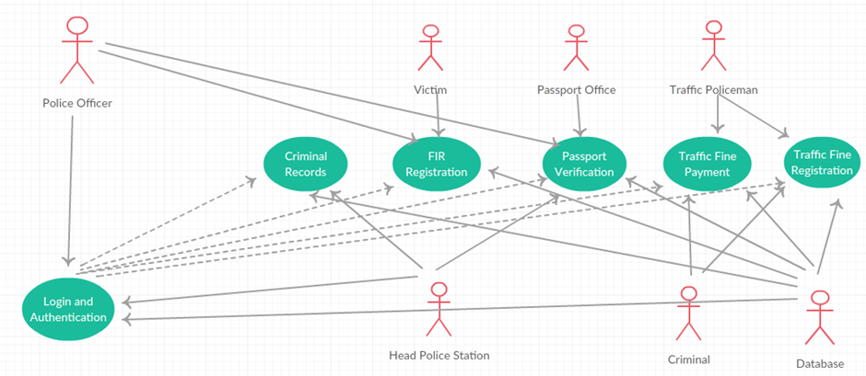

USE CASE | DESCRIPTION
Login and authentication | Authentication process for both head office and police departments
Criminal records | Database records which can be updated by head office and can be viewed by police officers
FIR Registration | FIR registrations can be updated and added by police stations.
Passport Verification | Passport can be verified by police officers.
Traffic receipt generation | Traffic receipt can be generated by traffic police
Cancel Registration | The registered users can apply for cancellation of their registration at any point of time.

Product Functions
- Online payment of fine.
- Online registration of FIR.
- Passport verification with a two tier confirmation system.
- Viewing and updating of a Criminal Database.
- Communication between various police departments.

User Characteristics
There are essentially two classes of users for the Police Administration System- Police Officers of the local police station and Police Officers of the Head Office. Both users must have basic knowledge of operating a computer system i.e. proficient in using a keyboard and a mouse. The user needs to know the exact nature of the submitted job as most of the functionalities are of high importance such as FIR Registration and Passport Verification.

Constraints
- GUI is only in English.
- All police stations require internet access.
- This system is working for single server.
- System is heavily dependent on internet service.
- Training of police required to use the system.

Assumptions and Dependencies
- All police stations have a computer system installed with net connectivity.
- Users of the system are well versed in operating a computer system.
- For the passport verification process, the passport application form has been already been submitted to the Passport Office.
- The receipt number for the payment of traffic fine should be present in the database.

External Interface Requirements
Software interfaces provide access to computer resources (such as memory, CPU, storage, etc.) of the underlying computer system.

- Client on Internet - Web Browser, Operating System (any)
- Web Server - Apache, Operating System (any)
- Data Base Server - MySQL, Operating System (any)
- Development End - Web Designing Tools (Django, Bootstrap, Java, JavaScript, HTML, CSS, XML, AJAX, MySQL), OS (Windows)

Hardware interfaces exist in many of the components in the various I/O devices etc. The various hardware interfaces required are:

- Processor
- RAM
- Memory Usage
- CPU Usage

Minimum requirements:

 |  | CLIENT SIDE
 | Processor |  | RAM | Disk Space
Internet Explorer-6 | Intel Pentium III or AMD  800 MHz |  | 128 MB | 100 MB

Table 2.2(a) Client side minimum requirements

 |  | SERVER SIDE
 | Processor | RAM | Disk Space
Web Designing Tools | Intel Pentium III or AMD  800 MHz | 1 GB | 3.5 GB
MySQL | Intel Pentium III or AMD  800 MHz | 256 MB | 500 MB(Excluding Data  Size)

Table 2.2(b) Server side minimum requirements

Recommended Requirements:

 |  | CLIENT SIDE
 | Processor | RAM | Disk Space
Internet Explorer-6 | All Intel or AMD - 1 GHZ | 256 MB | 100 MB

Table 2.2(b) Client side recommended requirements

 |  | SERVER SIDE
 | Processor | RAM | Disk Space
Web Designing Tools | All Intel or AMD - 2 GHZ | 2 GB | 3.5 GB
Internet Explorer-6 | All Intel or AMD - 2 GHZ | 512 MB | 500 MB(Excluding Data Size)

Table 2.2(c) Server side recommended requirements

Functional Requirements

Registration
This module allows first time users to register to use the administration site. Each registration is vetted by the admin of the website before being allowed to use the system.

Login
This module allows user to log into the system to avail the exclusive functionalities available to registered and verified police officers.

Traffic Fine Registration:
This module is to allow police officers to register traffic offenders. A form asks for the name of the offender, the receipt number assigned to him/her, the offence committed and the amount to be paid by the offender.

Traffic Fine Payment:
This module is to confirm payment of traffic fine payments. A form asks for the receipt number on the receipt issued to the violator. The database is searched for that particular receipt. If the status of the receipt is unpaid in the table, then the status is changed as payment has been received by the police officer at the desk. If the receipt doesn’t exist or a receipt number has been entered who’s status is already paid, appropriate message is displayed.

FIR Registration:
This module allows the lodging of an FIR complaint. A form takes in details from the victim such as name, address, criminal details and the form is submitted. There is also a facility for the police to view previously filed FIRs.

Criminal List
This is a page which lists pictures and details of the wanted criminals. Local police stations can only view the list. Head office police station has credentials to update it. The initial page allows us to click on individual criminal pictures to get detailed view.

Message Broadcast:
The message broadcasting module allows sending of messages between a police officer and the entire station.

Passport Verification

This is a two tier confirmation module. The local police station has a police officer who fills in the confirmation form which includes checking for proper documents to confirm whether the applicant is a citizen of India. Once the form is submitted, a police officer in the head office checks the form one last time and then forwards it to the passport office.

Non Functional Requirements

Response Time
The maximum response time for the submission of a job will be 1 seconds.

Bandwidth
The bandwidth for the internet should be sufficient to allow multiple officers to access the internet at the same time. This leads to effective multitasking.

Security Considerations
The system should ensure that sensitive information stored on databases should not be prone to hacking.

Scalability
Performance of the Police Administration System should not be deterred when workload increases. Multitasking capability is a major advantage the system provides.

Compatibility
The system should run on any web browser and on any operating system.

Schedule

